LAB 1-1 Create Storage Account Configure Monitoring & logging

1. Create Storage Account

Deployment Complete

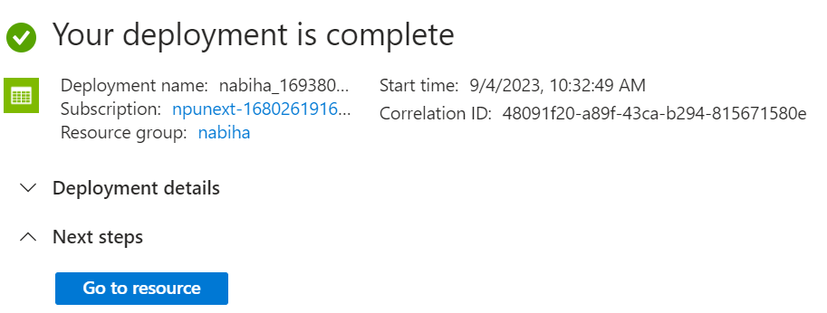

Creating Metrics

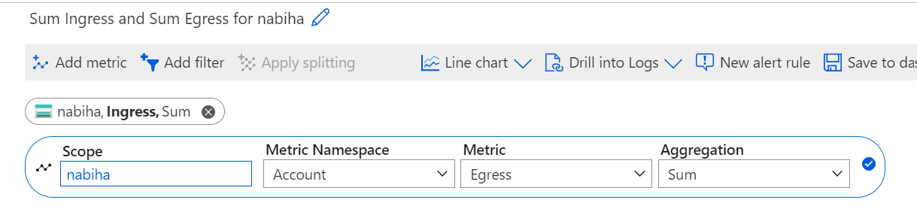

Alert Rules Created

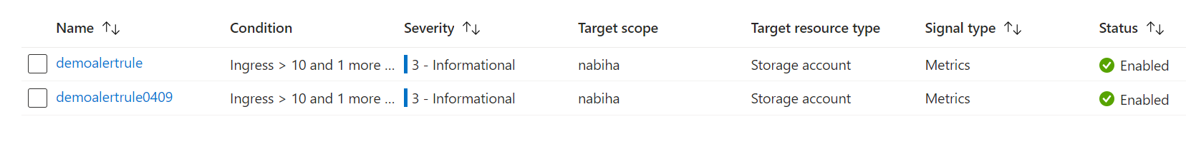

Container Created & File Uploaded

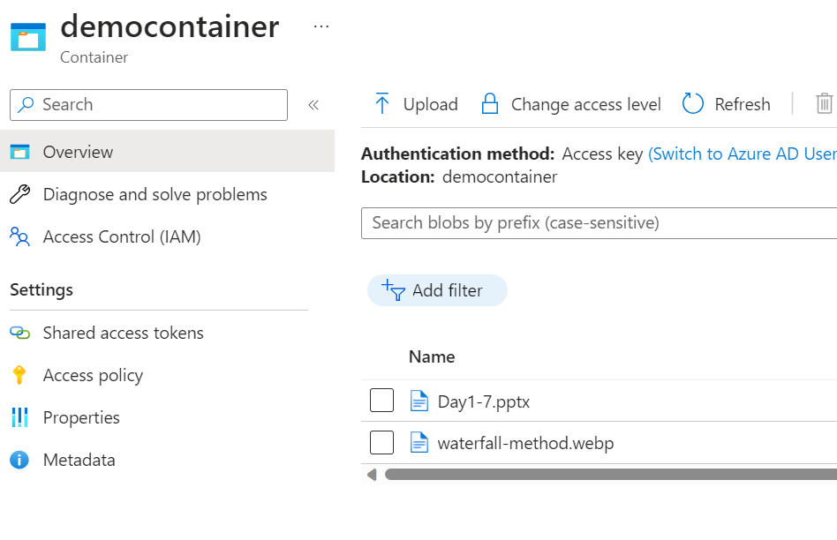

Alert Details

